**Polokwane international airport**

**Vision**

* For Polokwane International Airport to be recognized as a transformed and successful world class international airport that positively touches the lives of all people.

**Mission**

* PIA will be a commercially driven organization, committed to delivering excellent economic and social benefits for all its stakeholders.

**Our product**

* Airport infrastructure with no compromise in safety and security.

**Passenger Service**

* 3 Scheduled flights daily
* Charter flights
* Car rental companies
* Travel agencies.
* Shuttle Services
* Restaurant
* Office space for rent
* Shops for rental
* Hangers for rental

**CARGO**

* Future cargo hub
* Gateway into Southern Africa
* Development Countries
* Customized cargo facilities
* Future cold storage
* No congestion

**Conference Facilities**

* Offers more flexibilities
* Venue accommodates 10 to 2000 people
* Secluded
* Stunning conference rooms
* Good prices

**Hangers**

* Different sizes to suite clients’ needs
* Aircraft parking space

**Our infrastructure**

* Category 7 international license
* 945 hectares of land with potential to acquire more land
* 2 runways with lengths of 3175 meters and 2581 meters
* 4 aprons with parking capacity of 74800 sq meters
* Air traffic control and navigational aids
* Accessible through roads and rail
* Rescue and firefighting services.
* Passenger handling and aviation security
* Customs and excise
* Fueling services

**Investment opportunities**

* Working toward category 9 licensing status
* Extension of runways
* Construction of warehouses
* New passenger building
* Taxi way construction
* New tower
* Passenger terminal
* Cargo terminal
* Cold storage
* Cargo warehouse
* Available land for development

**What makes PIA different?**

* The location makes PIA a true gateway into Africa
* We are the first contact point from Europe or Africa into the RSA
* PIA gives easy and direct access to Kruger National Park, Game Farms and Lodges in Limpopo covering Waterberg and Maphungubwe areas

**About Polokwane**

* The fastest growing province in the country
* Theres plan to:
* Establish industrial development zone
* Introduce a fresh product market
* Build a convention Centre

These initiatives offer growth opportunities for the airport

* Polokwane borders Botswana, Mozambique and Zimbabwe

**Competitive edge of Limpopo**

* Infrastructure
* Roads and rail
* Natural resources-Agriculture, Mining
* Tourism

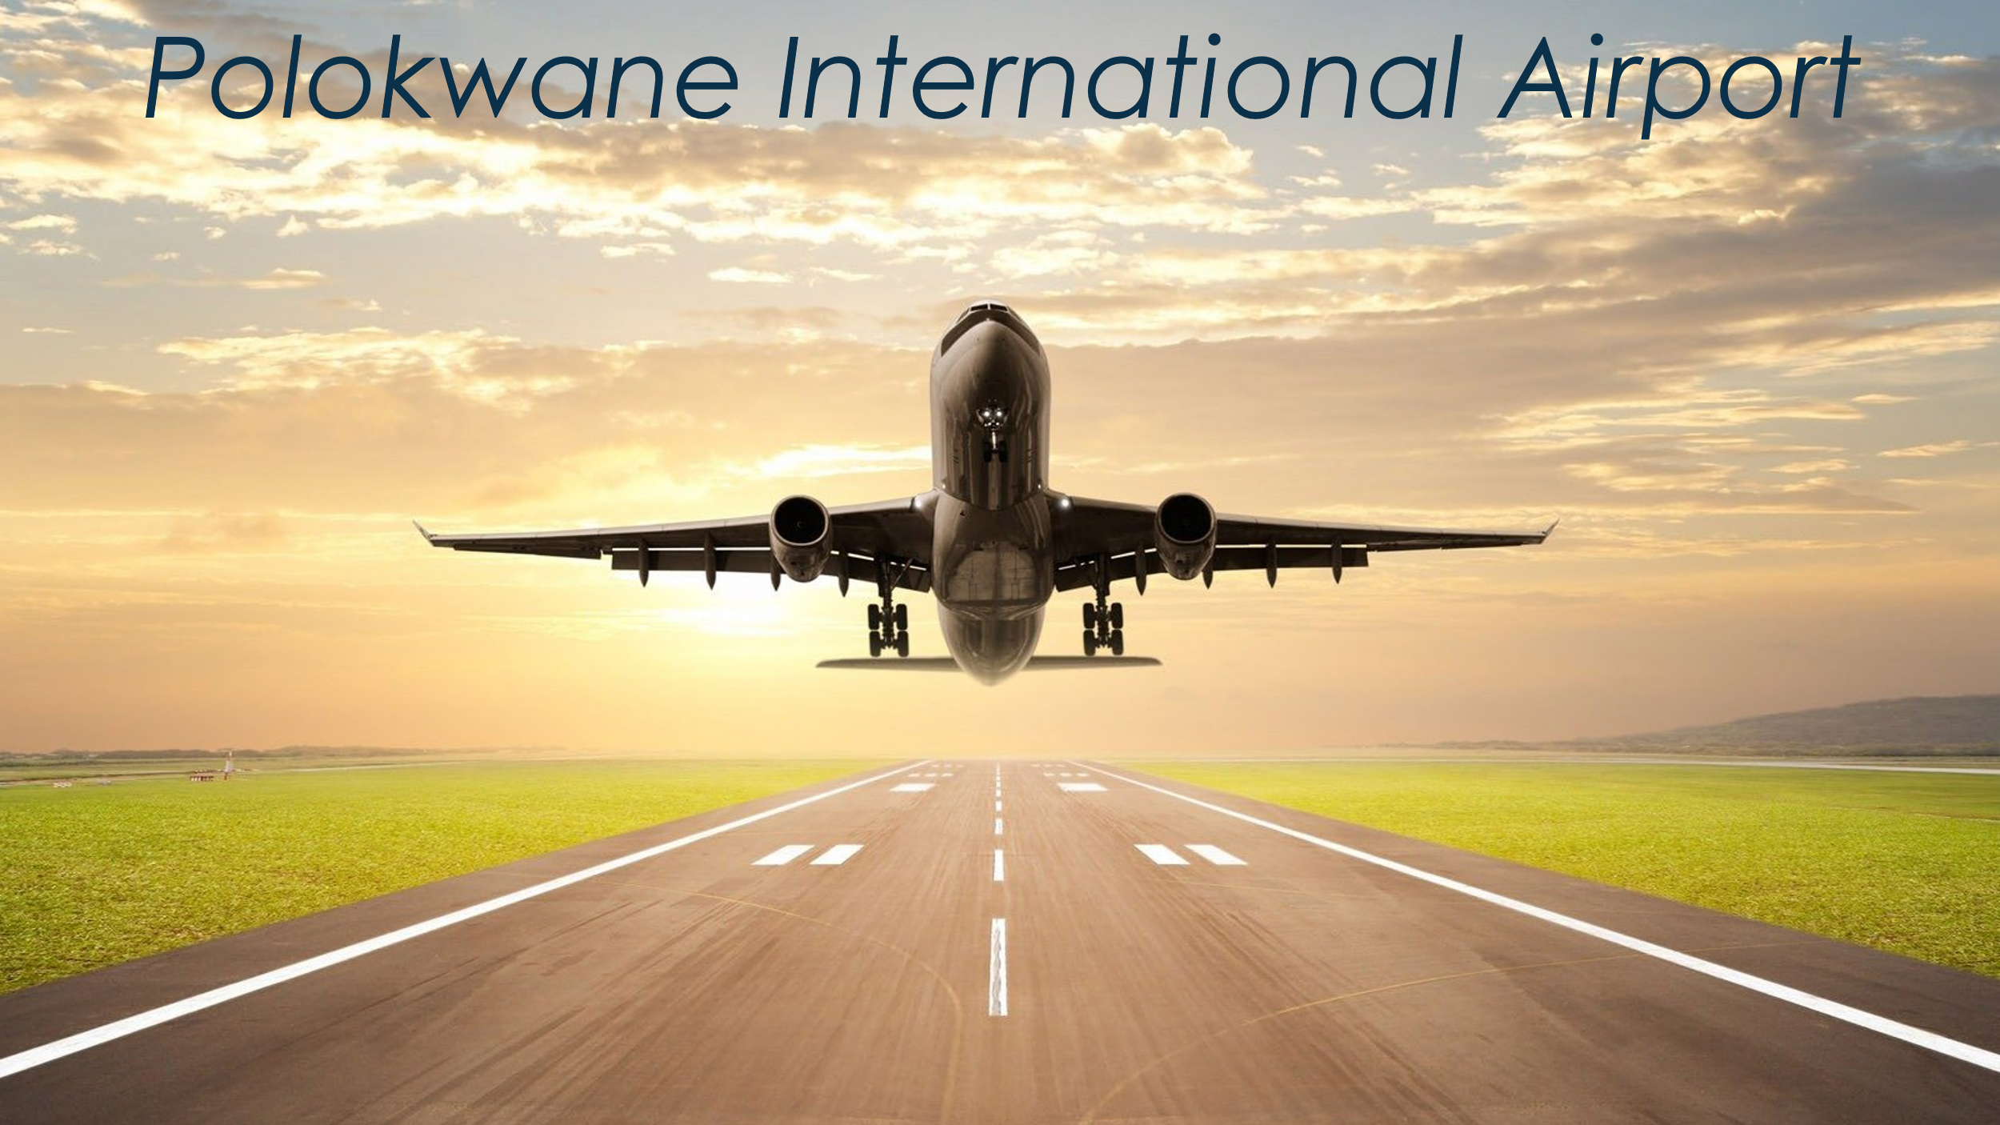

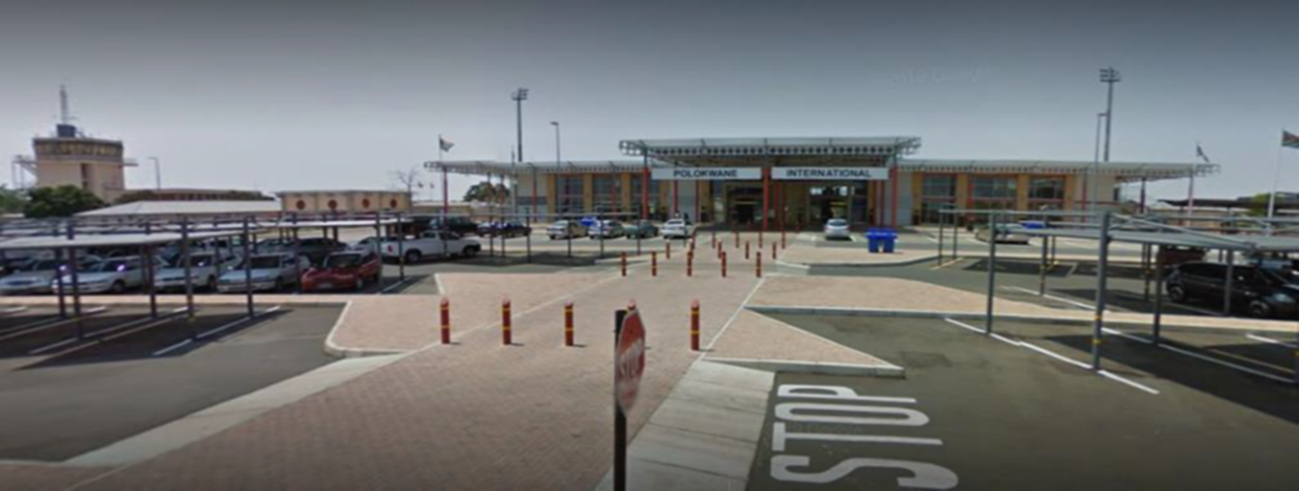

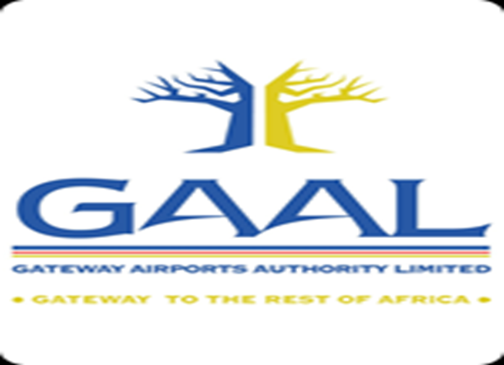

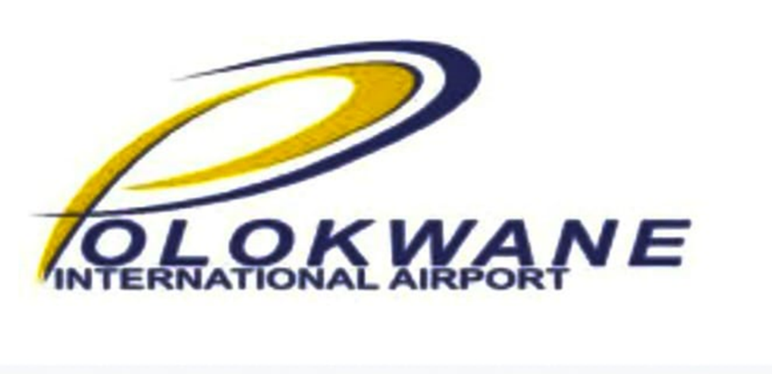

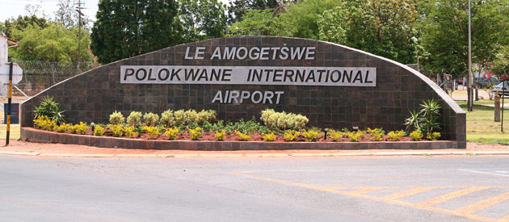

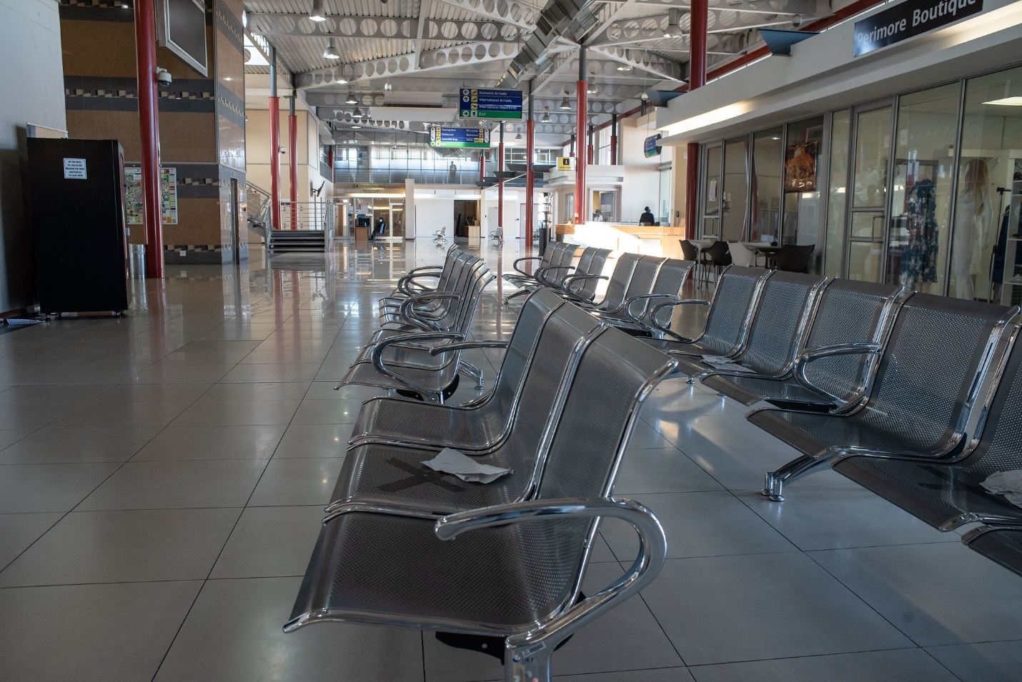

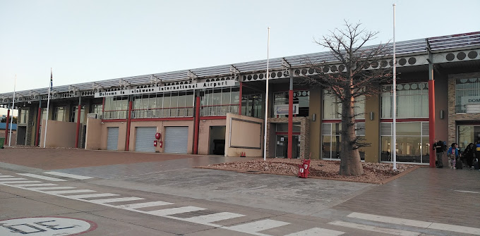

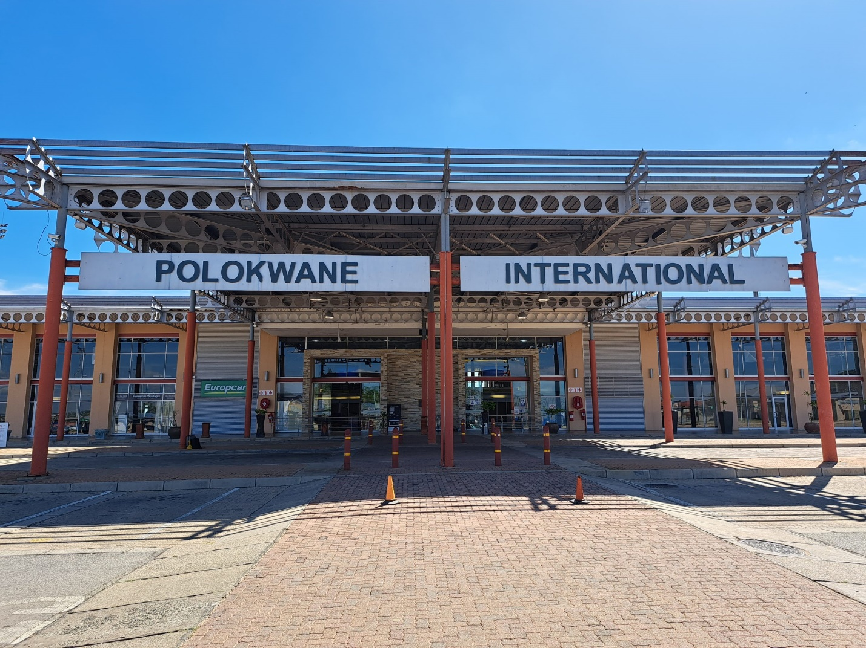

**Please search for more pics on line**